**ASSIGNMENT-7.1:**

7.1.1 Write a Mapreduce program to modify Sales of different TV Task 2 ( refer session 5 assignment 2 ) to use a custom partitioner with 4 reducers. Make sure that all records whose company name starts with A-F (upper or lower case) should go to 1st reducer, those starting with G-L to 2nd reducer, those starting with M-R to 3rd reducer and others to 4th reducer.

Driver Class:

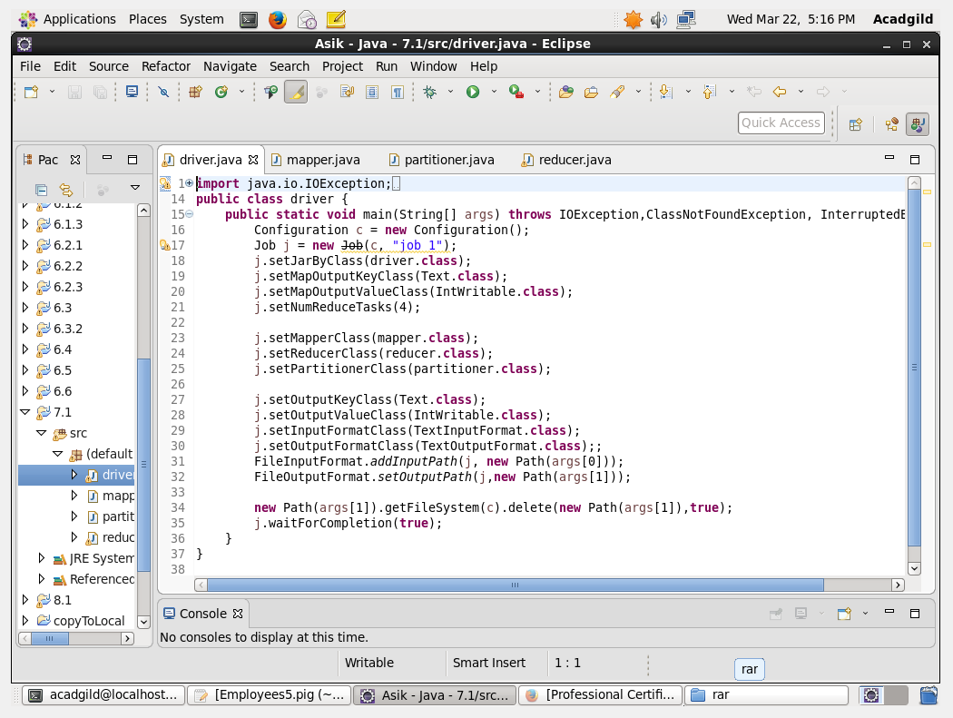

Mapper Class:

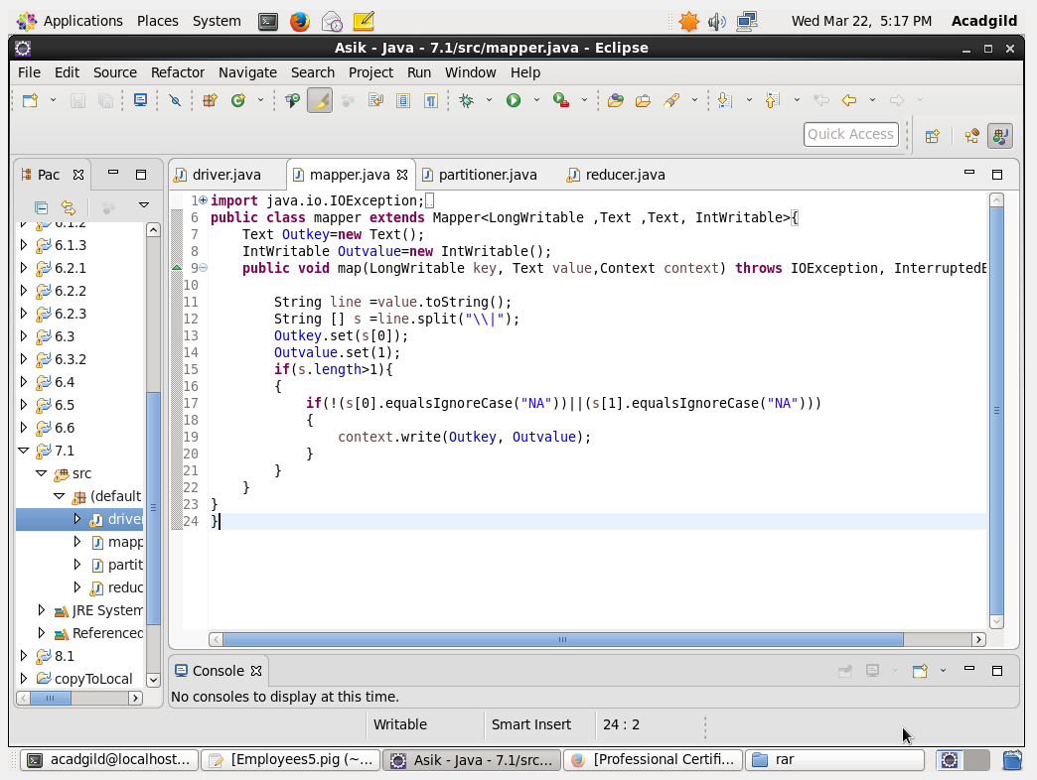

Reducer Class:

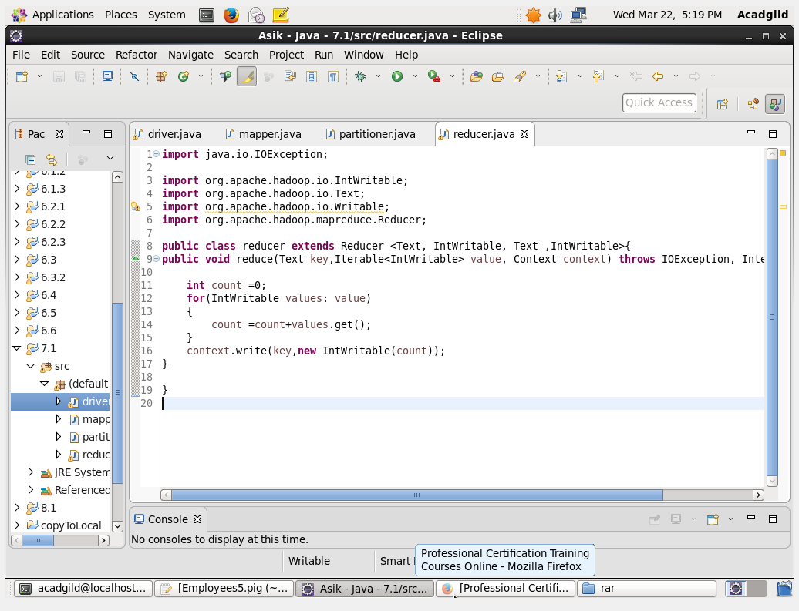

Partitioner Class:

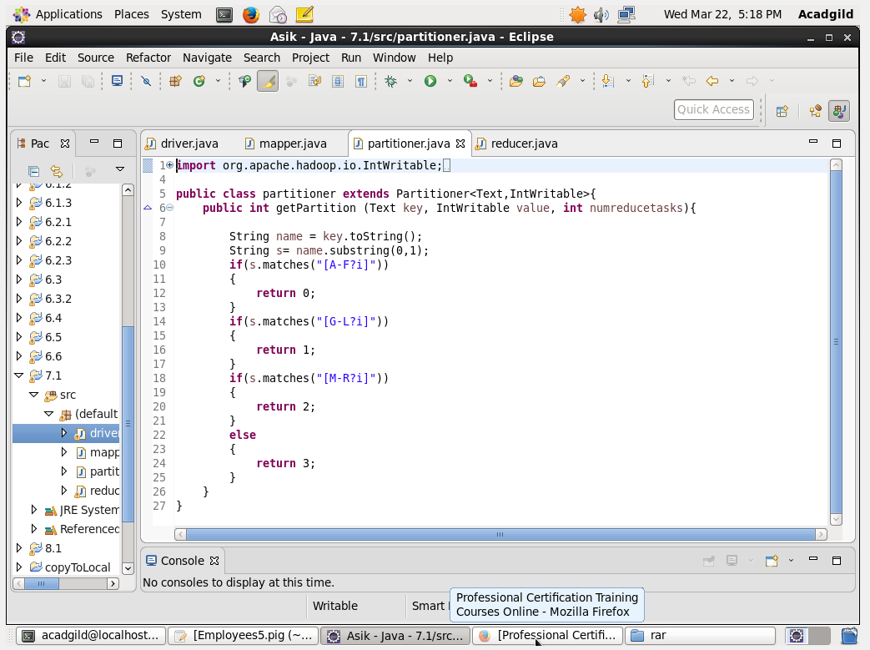

Output: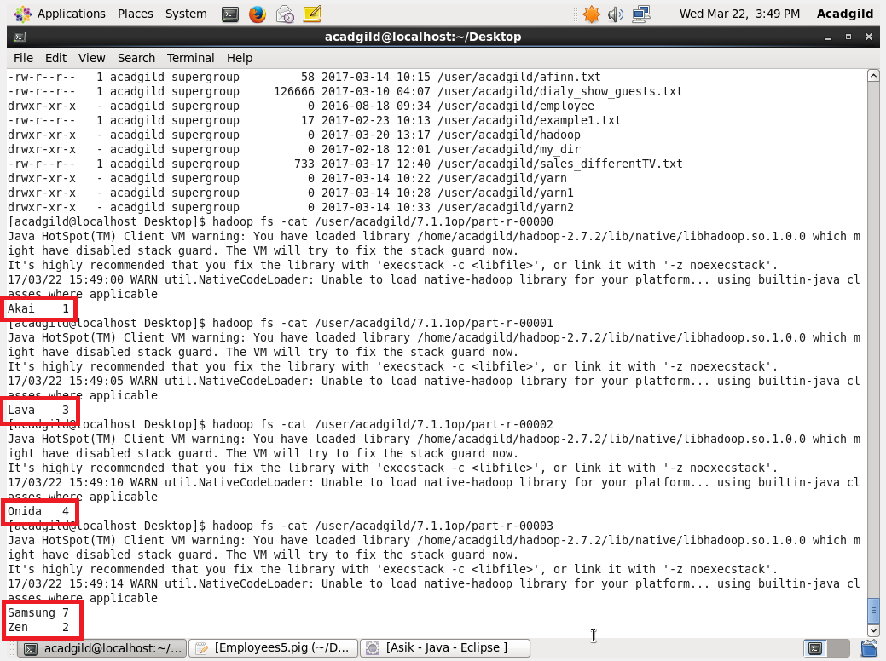

7.1.2 Modify Sales of different TV Task 2 (refer session 5, assignment 2) to take advantage of Combiner.

Driver Class:  
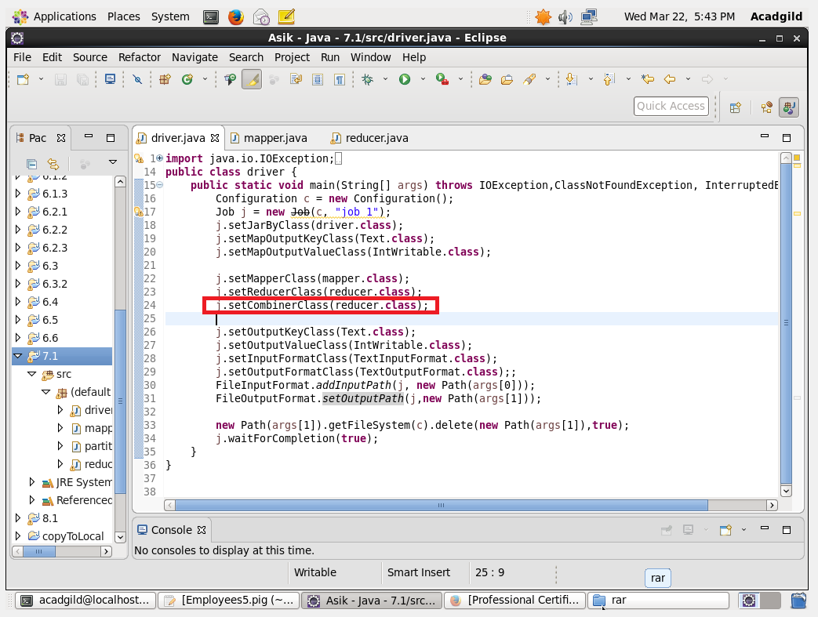

Mapper Class:

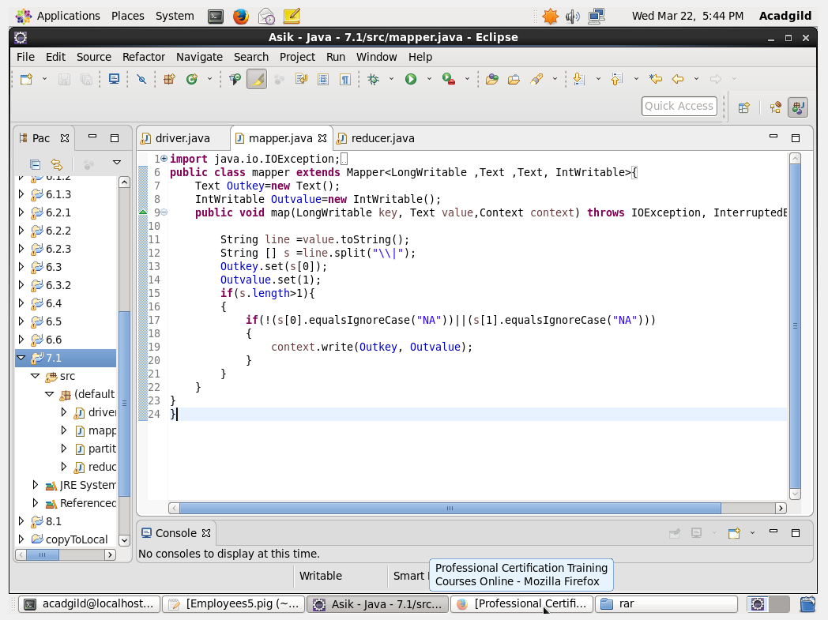

Reducer Class:

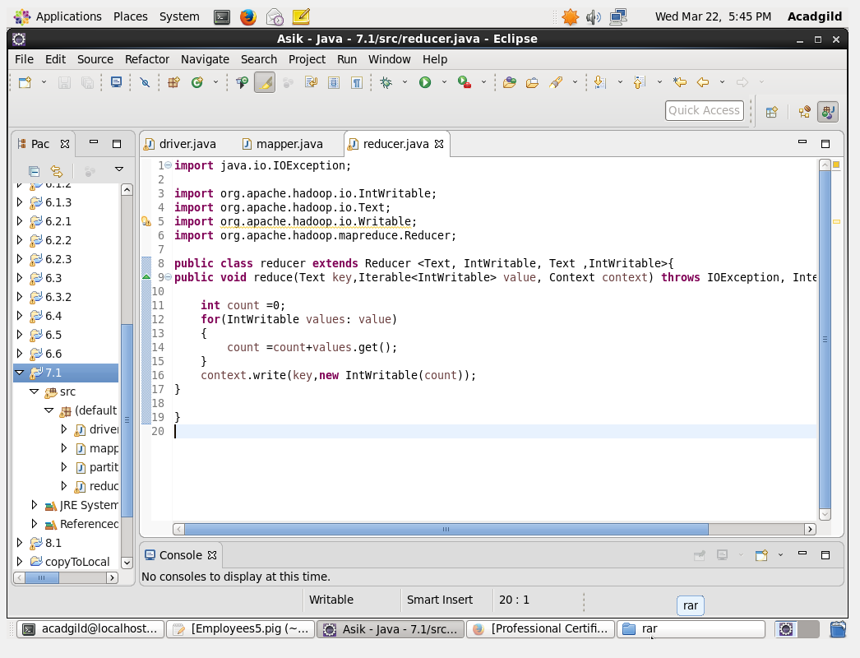

Output: